**Churn Retention & Prediction CRM**

**Industry**: Customer Relationship Management / Sales

**Project Type:** B2B/B2C Salesforce CRM Implementation

**Target Users:** Sales Managers, Customer Support Agents, Marketing Team, Executives

**Problem Statement:**  
Many businesses struggle to identify and retain customers who are at risk of leaving. Current processes rely on manual tracking or basic spreadsheets, resulting in:

* Difficulty identifying high-risk customers in time
* Inefficient communication and follow-up strategies
* Missed opportunities to offer personalized retention actions
* Limited insights for management decision-making

**Churn Retention & Prediction Solution:**

A Salesforce solution with a Flow-type chatbot to predict at-risk customers and automate retention actions, improving engagement and reducing churn. It provides personalized follow-ups, automated notifications, and dashboards for efficient customer management and decision-making

**Phase 1: Problem Understanding & Industry Analysis**

**1. Requirement Gathering:**

* Customer management (Name, Email, Phone, Account details, Subscription dates)
* Churn risk tracking (High, Medium, Low risk customers)
* Retention action management (Follow-ups, Offers, Notifications)
* Dashboard and reporting (At-risk customers, Retention success, Team performance)
* Automated notifications for follow-ups or subscription renewal reminders

**2. Stakeholder Analysis:**

* Sales/Support Manager: Full control over customer data, retention actions, and dashboards
* Support Agent/Marketer: Track at-risk customers, execute follow-ups, and update retention actions
* Executive: View analytics and overall churn trends for strategic decisions

**3. Business Process Mapping:**

1. Customer signs up → added to CRM
2. Assign subscription start/end dates → track active/expired status
3. Identify churn risk → categorize as high, medium, low
4. Assign retention action → send notifications or follow-ups
5. Generate reports → dashboards for churn trends and retention success

**4. Use Case Analysis:**

* Manual tracking of customer churn causes missed retention opportunities and delayed follow-ups
* Management cannot monitor real-time churn risk or retention efficiency

**5. AppExchange Exploration:**

* Explored apps like Salesforce Health Cloud (for customer tracking) and Retention Management tools for reference features

**Phase 2: org setup & configuration**

**Purpose:** Configure Salesforce org for Churn to ensure users, profiles, roles, and security settings are correct.

**Steps:**

1. **Salesforce Edition:** Developer Edition
2. **Company Profile Setup:** Name, Address, Timezone, Locale, Currency

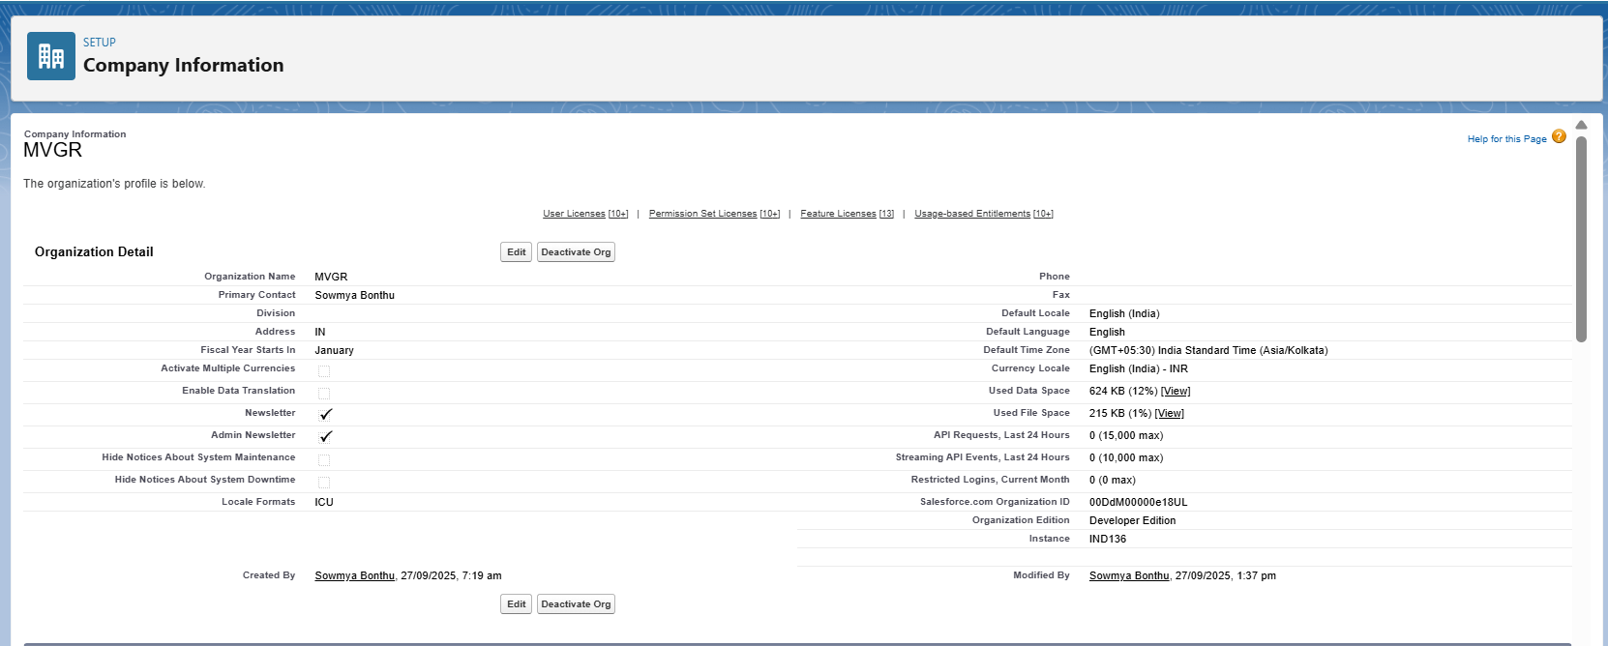

**3. Business Hours & Holidays:** Mon–Sun, 9 AM – 8 PM; include public holidays for support follow-ups

**4. Fiscal Year:** Standard

**5. User Setup & Licenses: Create sample users:**

* Admin: Full access to all customer data, retention actions, and dashboards
* Support Agent/Marketer: Manage at-risk customers, execute follow-ups, and update retention actions
* Receptionist/Assistant (optional): Create new customer records only

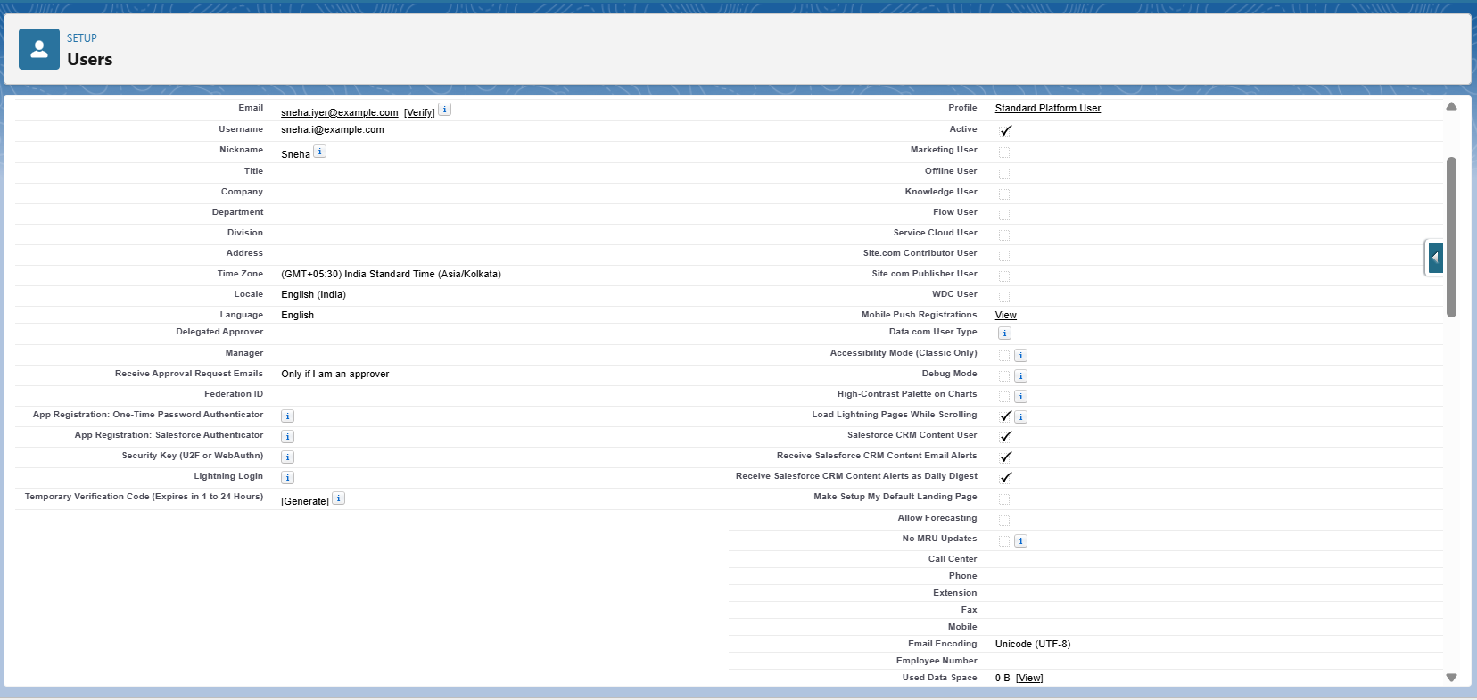

**6. Profiles:**

* Admin: Full access to all customer data, retention actions, and dashboards
* Support Agent/Marketer: Edit/View at-risk customers and retention actions
* Receptionist/Assistant (optional): Create/View customer records only

**7. Roles:** Admin > Support Agent/Marketer > Receptionist

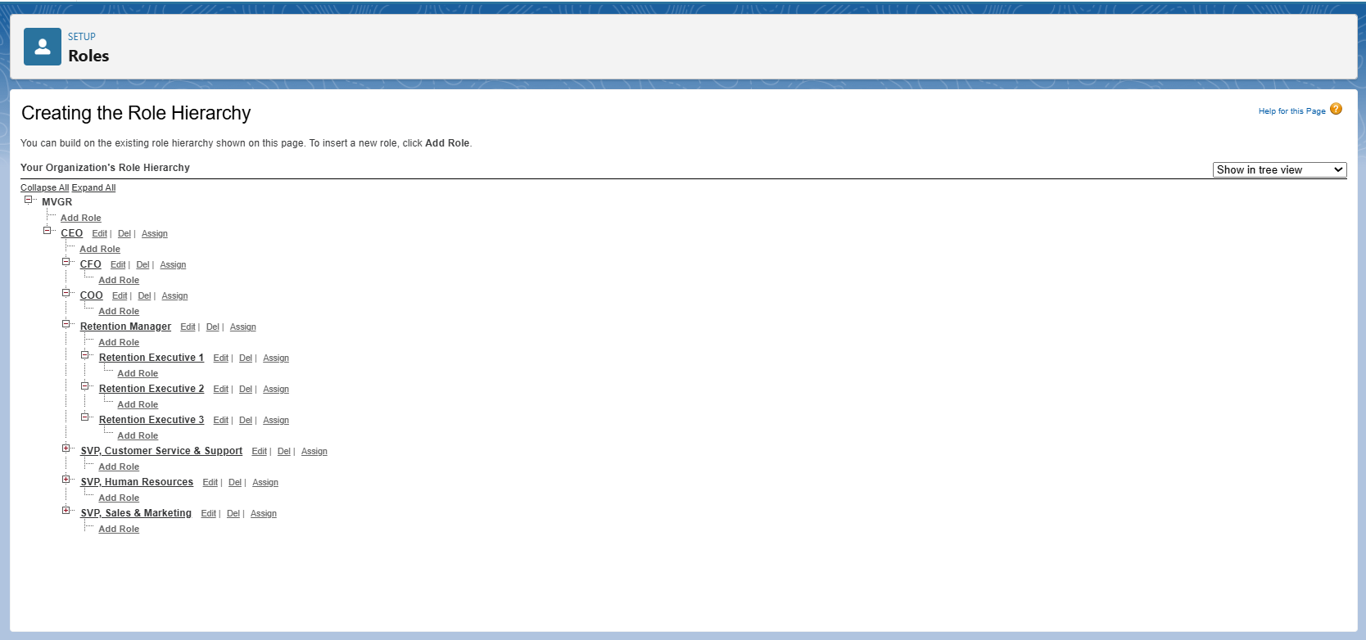

**8. Permission Sets:** Assign dashboard and report access for Support Agents

**9. OWD & Sharing Rules:**

* **Customers:** Private
* **Retention Actions:** Private
* **Sharing Rules:** Share customers with their assigned Support Agents for follow-ups

**10. Login Access Policies:** Admin can login as any user

**11. Sandbox Usage & Deployment Basics:** Optional for testing retention workflows and deployments in larger org setup

**Phase 3: Data Modeling & Relationships**

**Purpose:** Design objects and relationships for customer, churn risk, and retention action data.

**Custom Objects:**

* **Churn Risk:** Risk Level (High, Medium, Low), Reason, Last Interaction Date
* **Retention Action: Action Name, Type (Email, Call, Offer), Assigned Customer**
* **Follow-up Log: Date, Notes, Status, Linked Customer**

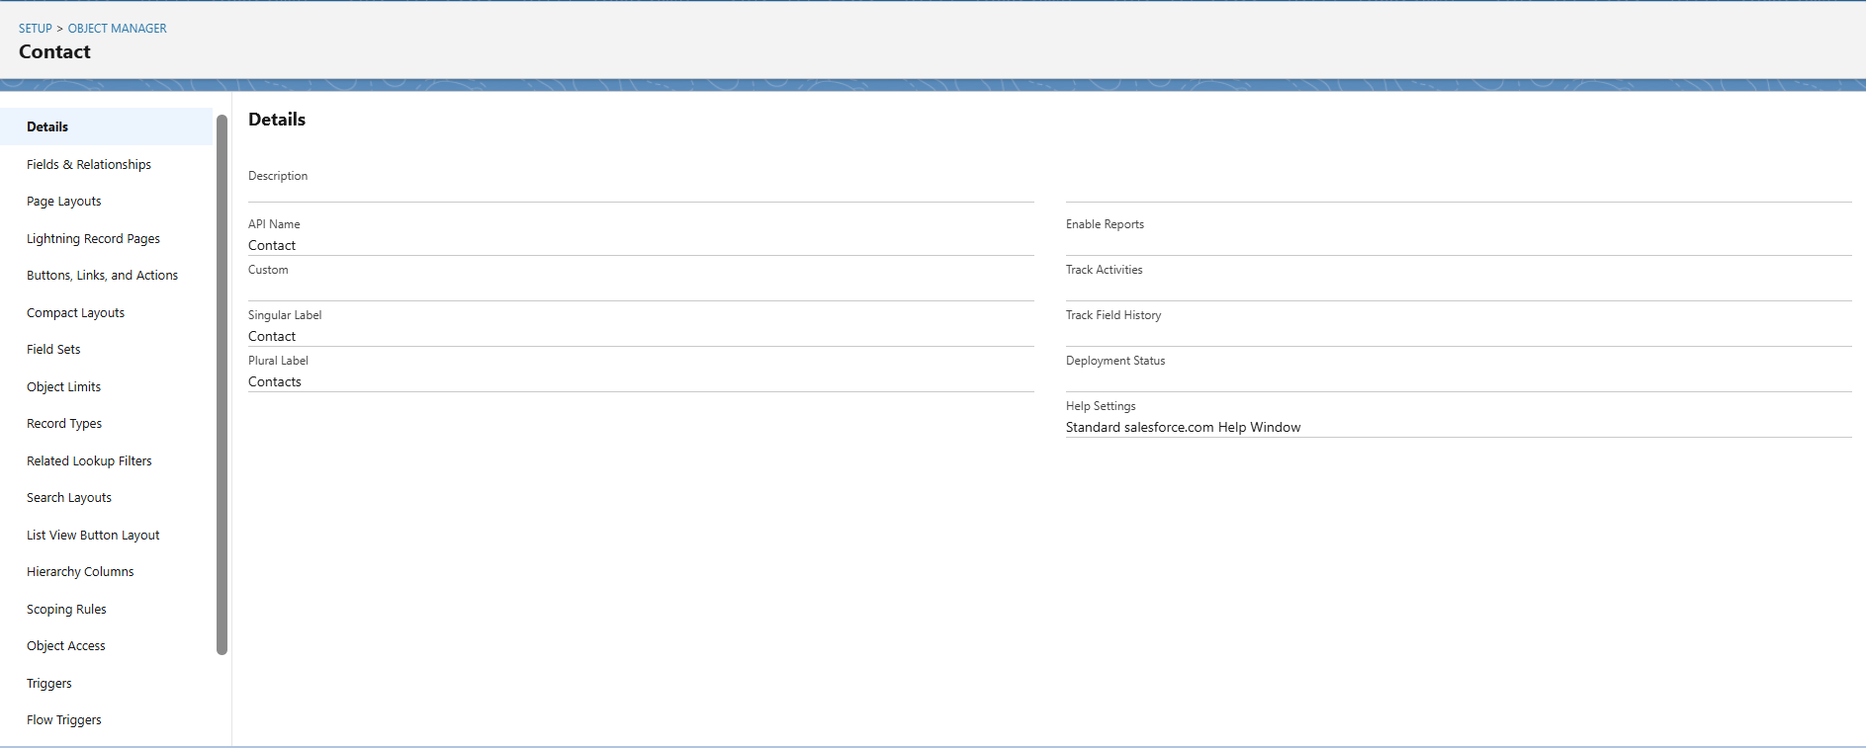

**Relationships:**

* **Contact ↔** Churn Risk → Lookup relationship (each customer has a churn risk record)
* **Contact ↔** Retention Action → Master-Detail (one customer can have multiple retention actions)
* **Contact ↔** Follow-up Log → Master-Detail (track multiple follow-ups per customer)

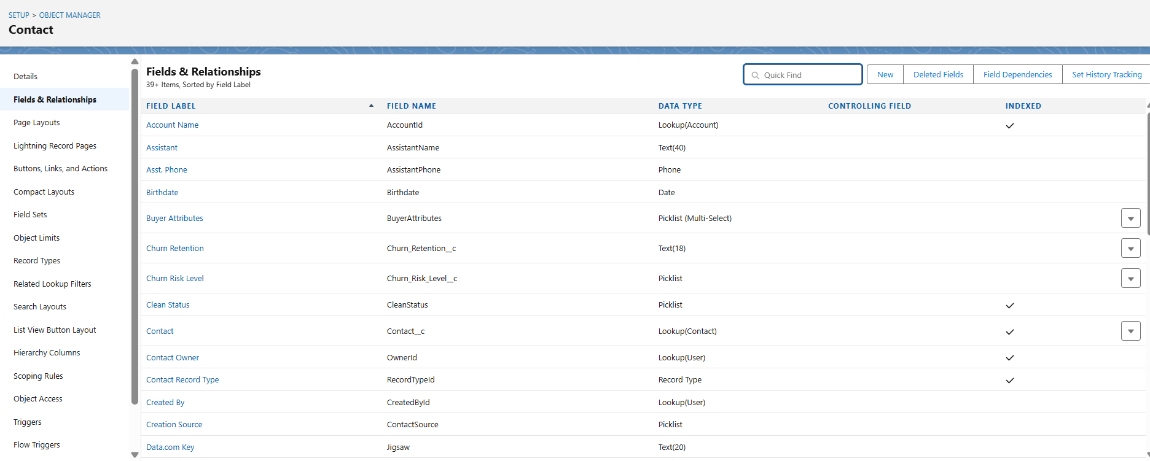

**Additional Configuration:**

* **Page Layouts:** Display key fields on Contact, Churn Risk, Retention Action, and Follow-up Log
* **Compact Layouts:** Show Name, Churn Risk Level, Last Follow-up Date
* **Schema Builder:** Visual diagram of objects and relationships to easily understand CRM structure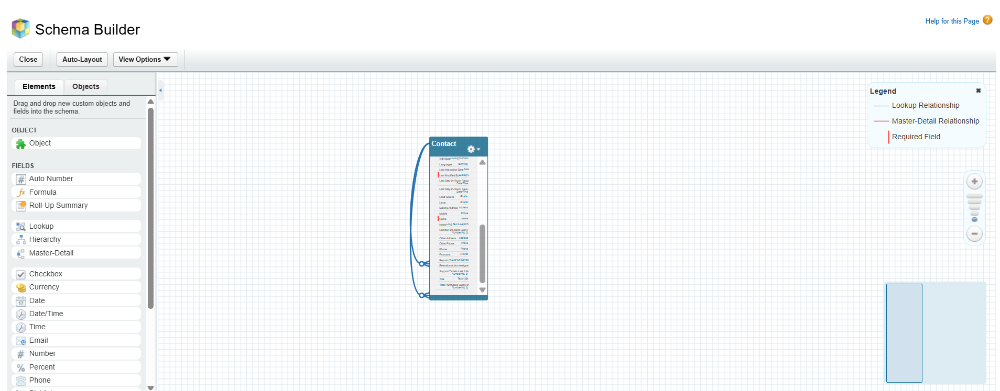

**Phase 4: Process Automation (Admin)  
Purpose:** Automate repetitive tasks, notifications, and retention follow-ups.

**Automation Examples:**

1. **Validation Rules:** Ensure Churn Risk Level >Email

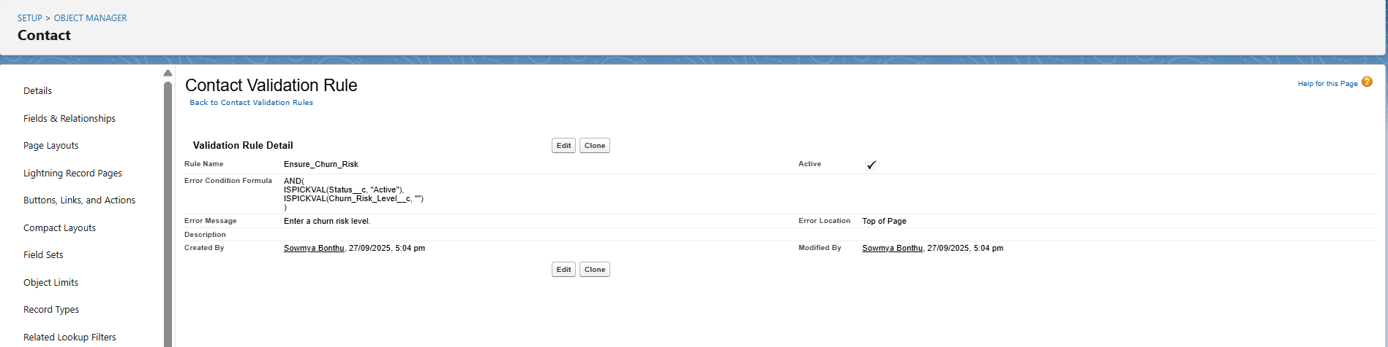

**Workflow / Process Builder:**

* Notify Admin/Support Agent when a customer is flagged as high-risk
* Auto-assign a default Retention Action based on churn risk if none is selected

**Flow Builder:**

* Auto-create “At-Risk Customers” report based on churn risk levels
* Automate retention reminders and notifications triggered by churn risk decisions

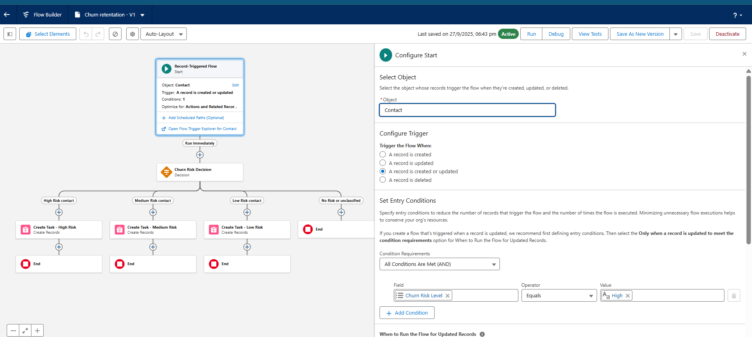

**Email Alerts / Custom Notifications:**

* Notify customers of retention offers, subscription renewal, or account updates
* Notify support agents when action is required for high-risk customers

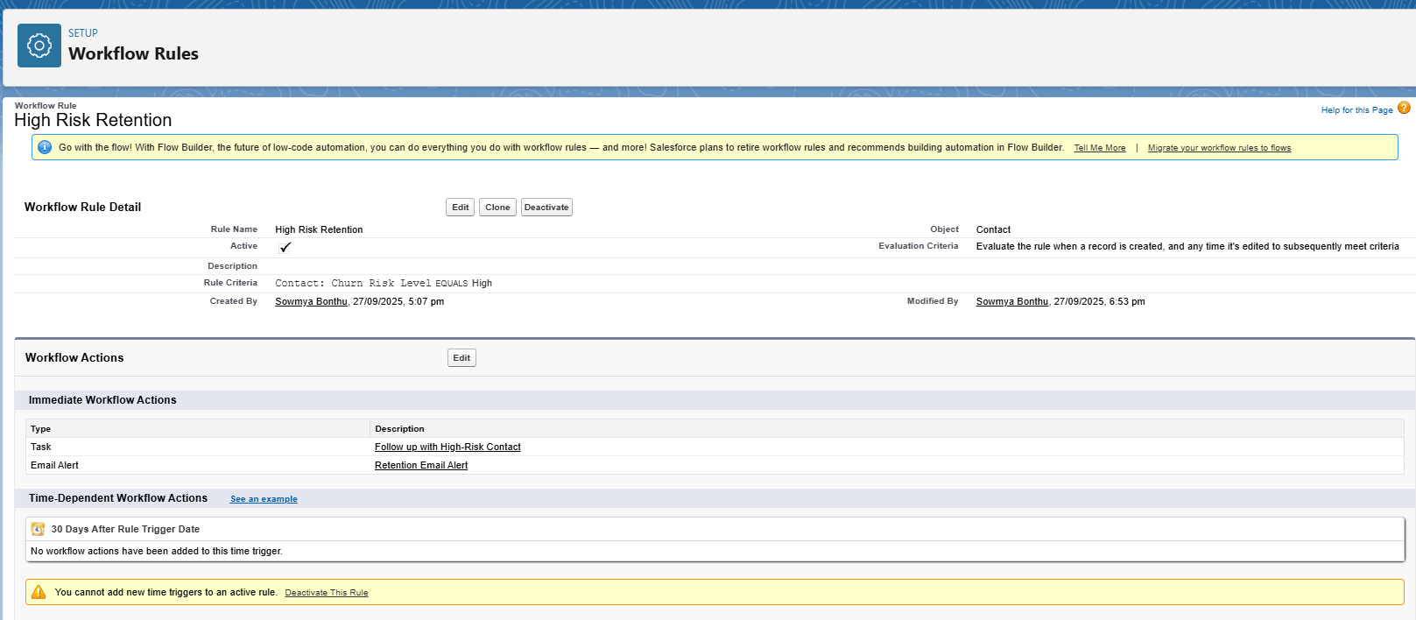

**Phase 5: Apex Programming (Developer)  
Purpose:** Use Apex code for advanced automation based on churn risk.

**Examples:**

**Triggers:**

* Customer Insert → Assign default **Retention Action** based on churn risk
* Churn Risk Update → **Notify support agent** via email

**Helper Classes:**

* Calculate **churn status** (High, Medium, Low)
* Determine retention priority

**Batch Apex / Queueable Apex:**

* Bulk update **at-risk customers** and send email alerts

**Test Classes:**

* For triggers and helper classes to meet Salesforce deployment requirements

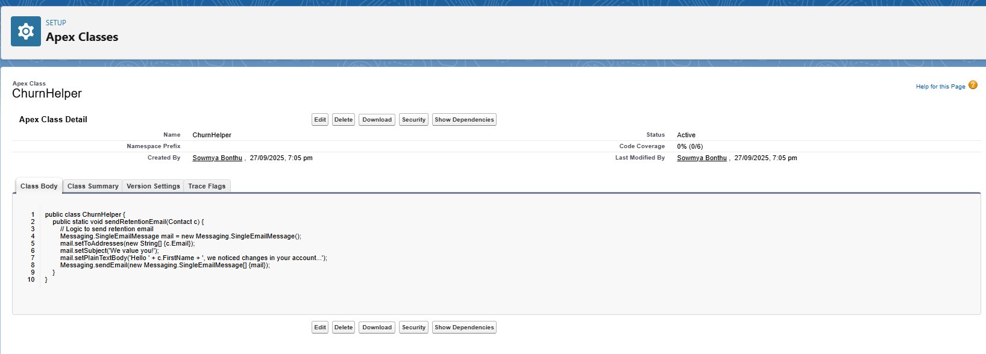

**Phase 6: User Interface Development  
Purpose:** Create a user-friendly experience for different roles.

**Steps:**

* Create Churn Retention App in Lightning App Builder

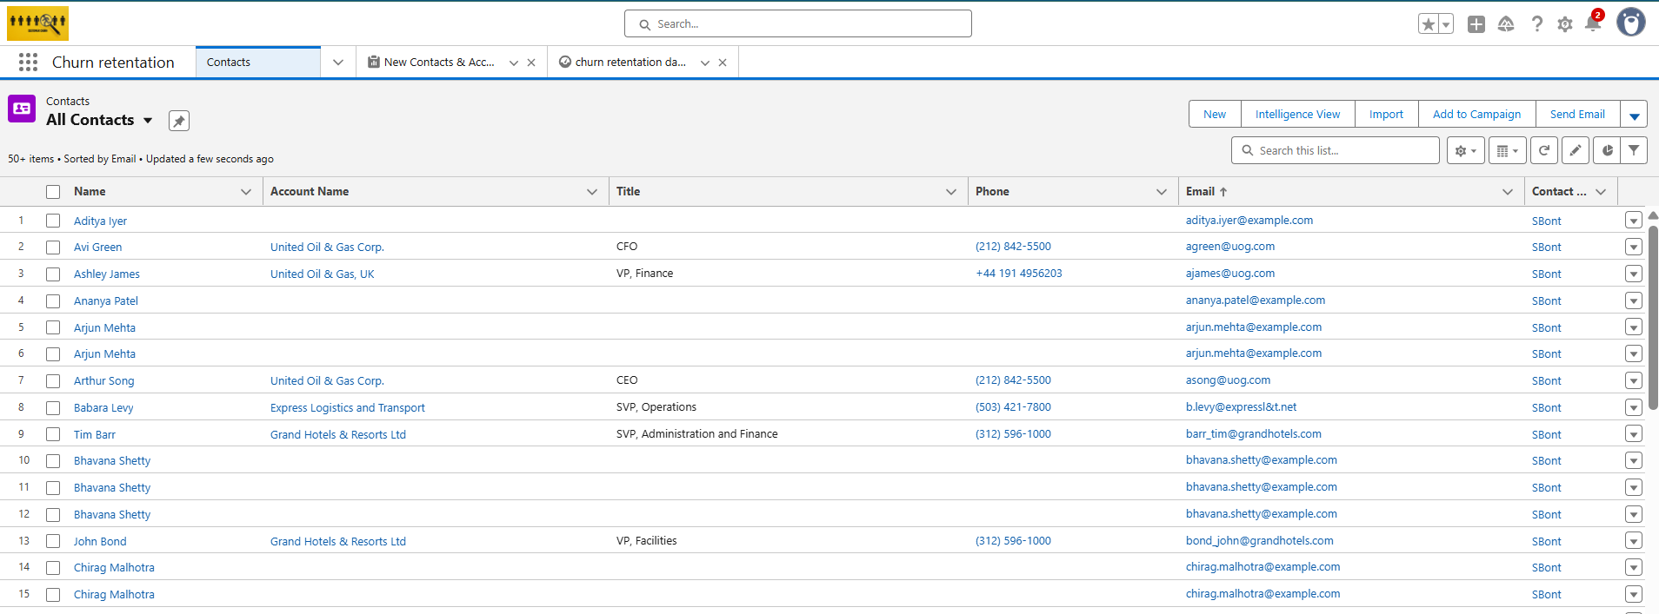

* **Add Tabs:** Accounts, Contacts, Leads, Reports, Dashboards, Churn, Prediction
* Customize Record Pages for Contacts and Churn objects
* **Home Page Layouts:** Dashboard showing High, Medium, Low-risk Customers, Retention Actions, and Support Agent Workload
* **Optional:** Lightning Web Component for customer search, churn prediction overview, or retention action tracking

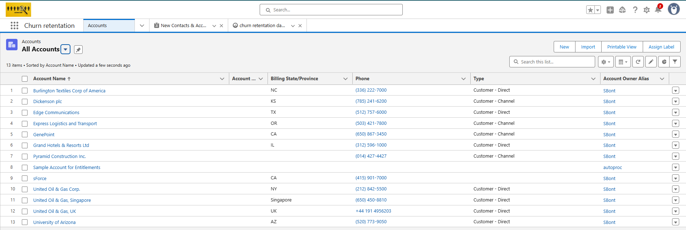

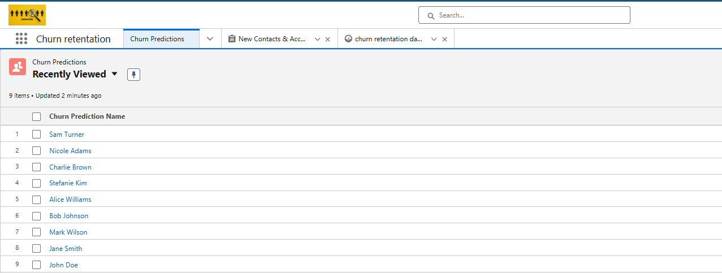

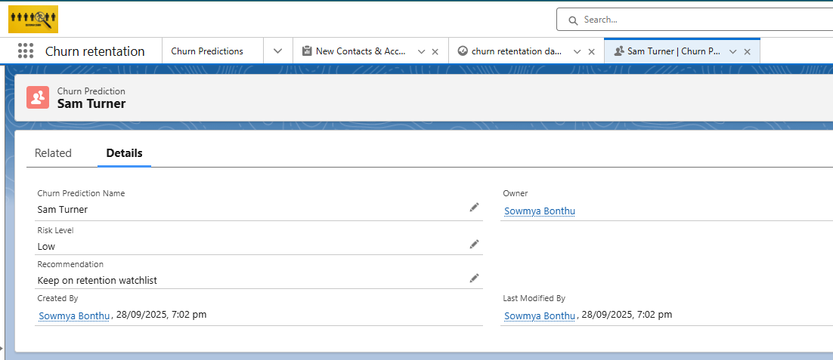

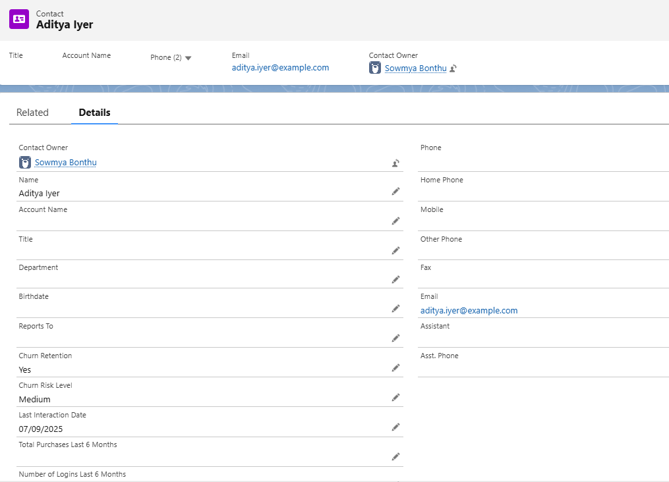

**Phase 7: Integration & External Access**  
**Purpose:** Connect Salesforce with external systems to enhance churn prediction and retention actions.

* **Named Credentials:** Connect with third-party APIs (email services, SMS gateways, marketing platforms)

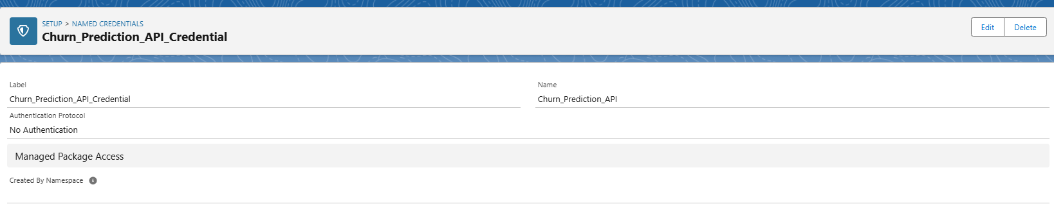

* **Platform Events:** Notify **support agents** when a customer’s churn risk changes or a retention action is assigned
* **Remote Site Settings:** Allow external API access for sending notifications or fetching customer engagement data

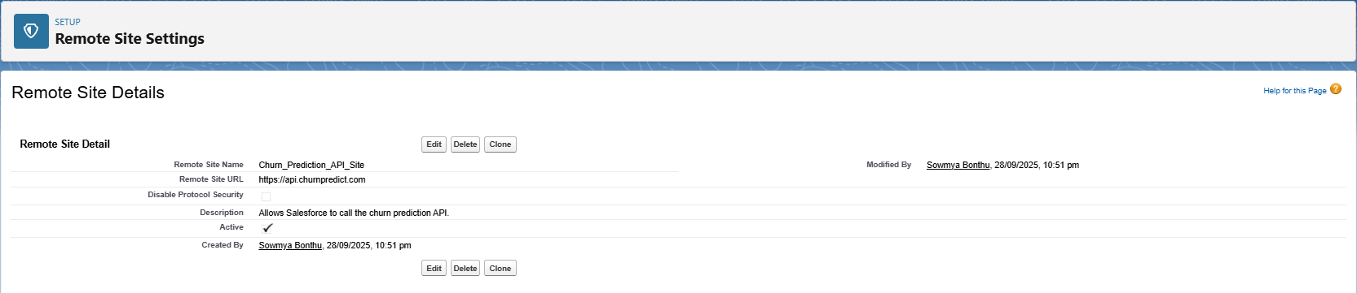

**Phase 8: Data Management & Deployment**  
**Purpose:** Ensure data integrity, smooth migrations, and secure management of customer and retention data.

**1. Data Import Wizard (UI-based import)**

* **Use Case:** Upload small datasets like sample **Contacts, Churn Risk, or Retention Actions** for testing.
* **Steps:**
  1. Go to App Launcher → search **Data Import Wizard**.
  2. Scroll down to Custom Objects → Select **Contact** or **Churn Risk**.
  3. Click **Launch Wizard**.
  4. Upload CSV (e.g., Name, Email, Churn Risk Level, Retention Action).
  5. Map fields → Click **Start Import** → Records uploaded.

**2. Data Loader (Bulk Import/Export)**

* **Use Case:** Upload large datasets (e.g., 500+ Contacts at once) or perform updates.
* **Steps:**
  1. Setup → search **Data Loader** → Download & Install.
  2. Open → Log in with Salesforce credentials.
  3. Choose operation: Insert, Update, insert, Delete, Export.
  4. Example: Insert → Contact or Churn Risk object → Upload CSV → Map fields → Run.

**3. Duplicate Rules (Data Quality Control)**

* **Use Case:** Prevent duplicate customer records (same email or phone).
* **Steps:**
  1. Setup → search **Duplicate Rules** → New Rule → Select **Contact**.
  2. Define rule: Check **Email or Phone**.
  3. Action: Alert or Block → Save & Activate.

**4. Change Sets / Deployment**

* **Use Case:** Move **Contacts, Churn Risk, Retention Actions, Reports, Dashboards** from sandbox → production.
* **Steps:**
  1. Setup → search **Outbound Change Sets** → Create new → Name: “Churn Retention Deployment”.
  2. Add Components → Upload → Target Org → Approve & Deploy.

**5. Export / Backup**

* **Use Case:** Monthly backup of Contacts & Churn Risk data.
* **Steps:**
  1. Setup → search **Data Export** → Select **Contacts, Churn Risk, Retention Actions**.
  2. Frequency: Monthly → Salesforce generates ZIP with CSVs → Download.

**Phase 9: Reporting, Dashboards & Security Review**  
**Purpose:** Track customer churn, retention effectiveness, and team performance.

**Reports:**

* At-Risk Customers by Churn Level (High, Medium, Low) – Summary or Matrix
* Retention Actions Completed by Support Agent – Summary
* Customers per Retention Action Type – Tabular

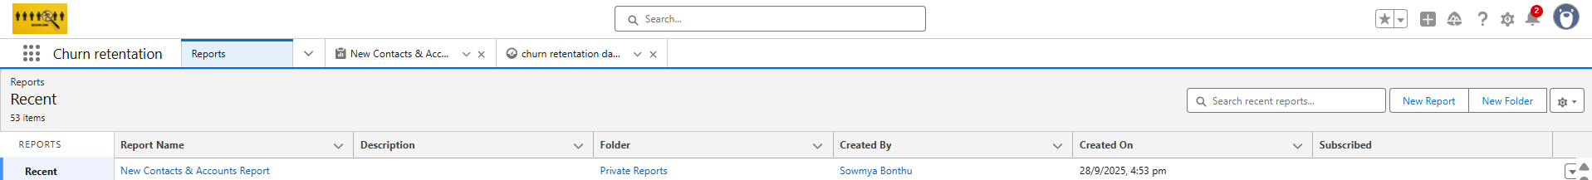

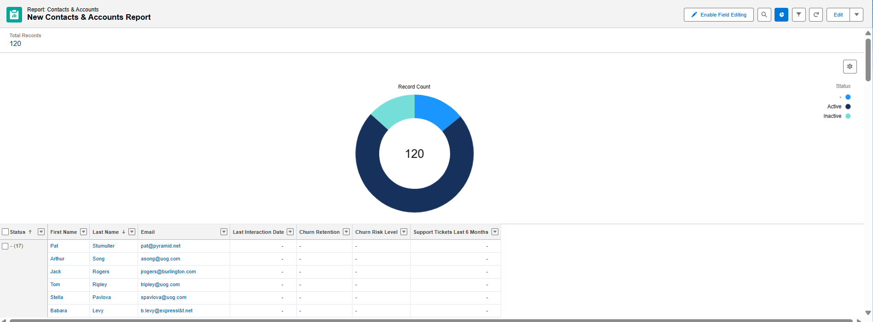

**Dashboards:**

* Donut Chart → High vs Medium vs Low-risk Customers
* Bar Chart → Customers handled per Support Agent
* Line/Trend Chart → Retention action success over time

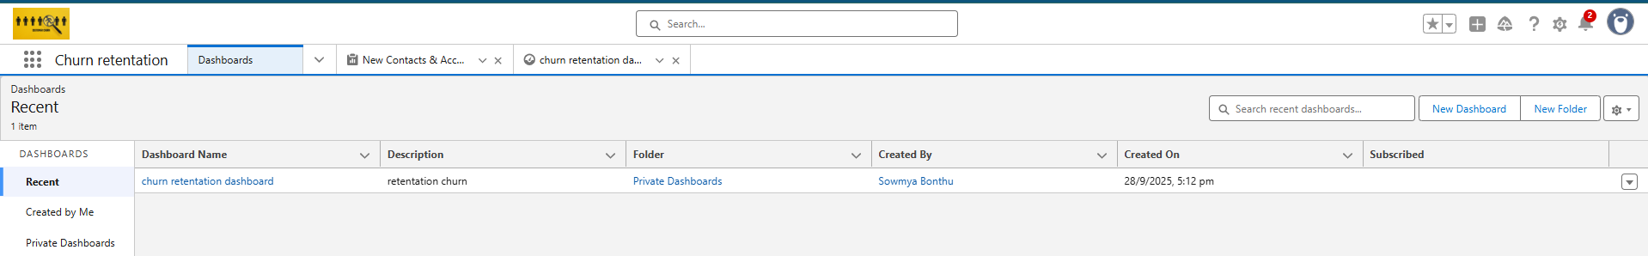

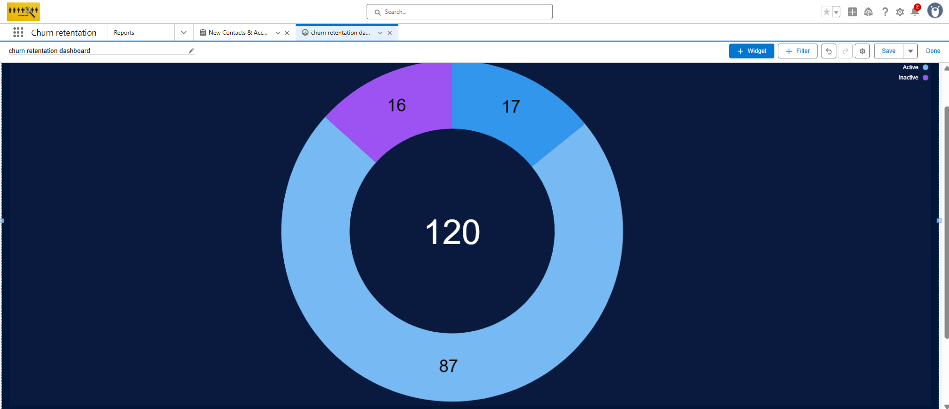

**Security:**

* Field-Level Security for sensitive data (Email, Subscription Details)
* Sharing Rules applied for role-based access (Admin > Support Agent > Assistant)
* Audit Trail for all changes in Churn Risk and Retention Actions

**Phase 10: Final Presentation & Demo Day**  
**Purpose:** Showcase the project and demonstrate its features.

**Pitch:** Explain the **customer churn problem**, your **Salesforce solution**, and key **Churn Retention features**.

**Demo Walkthrough:**

1. Create a new **Contact / Customer**
2. Assign **Churn Risk Level** (High, Medium, Low)
3. Assign or trigger **Retention Action** based on risk
4. Show **dashboards**: At-Risk Customers, Retention Actions, Support Agent Workload

**Feedback Collection:** Gather input from mentors, peers, or stakeholders

**Handoff Documentation:** Include project report, screenshots, and GitHub repository (if any)

**Portfolio Showcase:** Add project to LinkedIn, resume, or personal portfolio to highlight Salesforce and churn retention skills